**20CS2016L – Database Systems Lab URK22AI1004**

|  |  |
| --- | --- |
| Ex no: 2 | Basic SQL commands |
| Date | 09-01-2024 |

AIM:

To implement and executed basic DML commands in SQL.

DESCRIPTION:

SQL (Structured Query Language) may be an effective language utilized to communicate with databases. It is used to make, adjust, and oversee information stored in relational databases. It can be used to query, insert, upgrade, and erase records from the database, as well as create and adjust the structure of the database itself. It could be a very versatile dialect and can be utilized to perform complex queries and control huge amounts of information. SQL is the foremost commonly utilized language for databases and is utilized in a wide assortment of program applications.

**SELECT DML Command**

SELECT is the most important data manipulation command in Structured Query Language. The SELECT command shows the records of the specified table. It also shows the particular record of a particular column by using the WHERE clause.

Syntax of SELECT DML command

SELECT column_Name_1, column_Name_2, ….., column_Name_N FROM Name_of_table;

## INSERT DML Command

INSERT is another most important data manipulation command in Structured Query Language, which allows users to insert data in database tables.

**Syntax of INSERT Command**

INSERT INTO TABLE_NAME ( column_Name1 , column_Name2 , column_Name3 , .... column_NameN )  VALUES (value_

## UPDATE DML Command

UPDATE is another important data manipulation command in Structured Query Language, which allows users to update or modify the existing data in database tables.

**Syntax of UPDATE Command**

UPDATE Table_name SET [column_name1= value_1, ….., column_nameN = value_N] WHERE CONDITION;

## DELETE DML Command

DELETE is a DML command that allows SQL users to remove single or multiple existing records from the database tables.

This command of Data Manipulation Language does not delete the stored data permanently from the database. We use the WHERE clause with the DELETE command to select specific rows from the table.

**Syntax of DELETE Command**

DELETE FROM Table_Name WHERE condition;

QUERIES AND OUTPUT SCREENSHOT:

User Table:

|  |  |  |  |  |
| --- | --- | --- | --- | --- |
| **UserID** | **Name** | **Email** | **Password** | **Phone** |
| 1 | John Smith | john.smith@example.com | password1 | 12345678901 |
| 2 | Jane Doe | jane.doe@example.com | p@ssw0rd | 98765432101 |
| 3 | Michael Lee | michael.lee@example.com | 12345678 | 44332211000 |
| 4 | Sarah Adams | sarah.adams@example.com | sAdams123 | 11223344556 |
| 5 | David Wang | david.wang@example.com | dWang2023 | 65432109876 |
| 6 | Emily Chen | emily.chen@example.com | chen123 | 91827364560 |
| 7 | Alex Kim | alex.kim@example.com | kimAlex22 | 55566677788 |
| 8 | Lisa Lopez | lisa.lopez@example.com | lisa123 | 99900011122 |

Event Table:

|  |  |  |  |  |  |
| --- | --- | --- | --- | --- | --- |
| **EventID** | **Name** | **Date** | **Time** | **VenueID** | **Description** |
| 1 | Concert in Park | 15-08-2023 | 18:00 | 101 | Enjoy a live concert in the city park. |
| 2 | Movie Night | 20-08-2023 | 20:30 | 102 | Movie night under the stars. |
| 3 | Sports Tournament | 05-09-2023 | 14:00 | 103 | Join us for an exciting sports tournament. |
| 4 | Art Exhibition | 10-09-2023 | 12:00 | 104 | Explore various artworks by local artists. |
| 5 | Food Festival | 25-09-2023 | 11:00 | 105 | A celebration of diverse cuisines. |
| 6 | Comedy Show | 01-10-2023 | 19:30 | 106 | Laugh your heart out at our comedy show. |
| 7 | Tech Conference | 15-10-2023 | 09:00 | 107 | Join tech experts for informative sessions. |
| 8 | Dance Workshop | 05-11-2023 | 16:00 | 108 | Learn various dance styles in this workshop. |

Venue Table:

|  |  |  |  |  |  |
| --- | --- | --- | --- | --- | --- |
| **VenueID** | **Name** | **Address** | **City** | **State** | **Country** |
| 101 | City Park | 123 Park Street | New York | NY | USA |
| 102 | Open Field | 456 Meadow Lane | Los Angeles | CA | USA |
| 103 | Sports Arena | 789 Stadium Road | Chicago | IL | USA |
| 104 | Art Gallery | 101 Art Avenue | San Francisco | CA | USA |
| 105 | Event Center | 555 Celebration Boulevard | Miami | FL | USA |
| 106 | Comedy Club | 777 Laughter Street | Houston | TX | USA |
| 107 | Convention Center | 999 Tech Avenue | Seattle | WA | USA |
| 108 | Dance Studio | 222 Rhythm Road | Boston | MA | USA |

Ticket table:

|  |  |  |  |  |  |
| --- | --- | --- | --- | --- | --- |
| **TicketID** | **EventID** | **UserID** | **SeatNumber** | **Price** | **Status** |
| 1 | 1 | 1 | A1 | 25 | Booked |
| 2 | 1 | 2 | B2 | 25 | Booked |
| 3 | 2 | 3 | C3 | 15 | Booked |
| 4 | 2 | 4 | D4 | 15 | Booked |
| 5 | 3 | 5 | A2 | 10 | Booked |
| 6 | 3 | 6 | B3 | 10 | Booked |
| 7 | 4 | 7 | C4 | 8.5 | Booked |
| 8 | 4 | 8 | D5 | 8.5 | Booked |

1. Retrieve the details of users whose names contain "Smith."

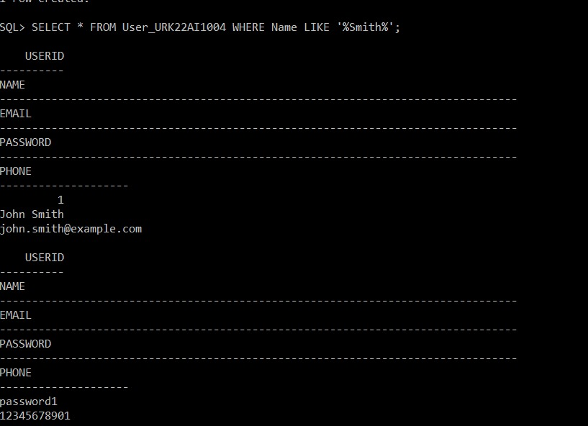

1. Display the details of users whose passwords are not equal to "password1."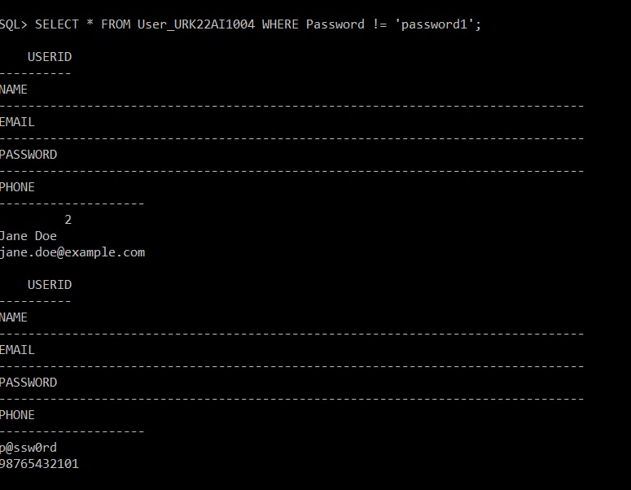

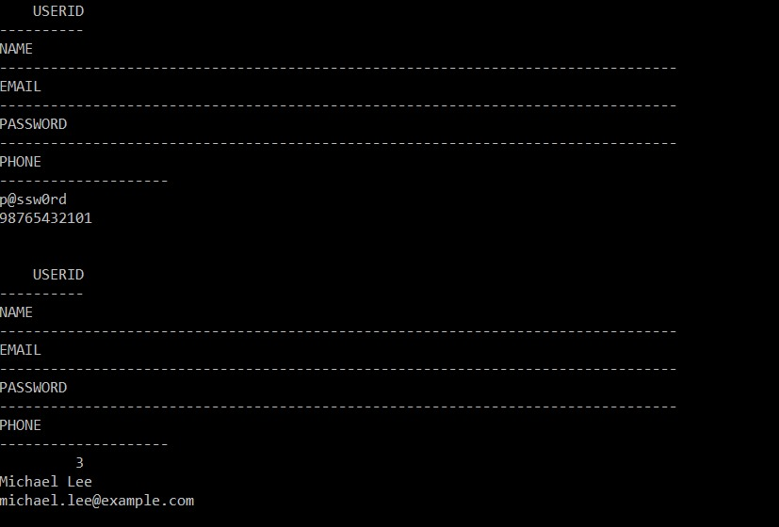

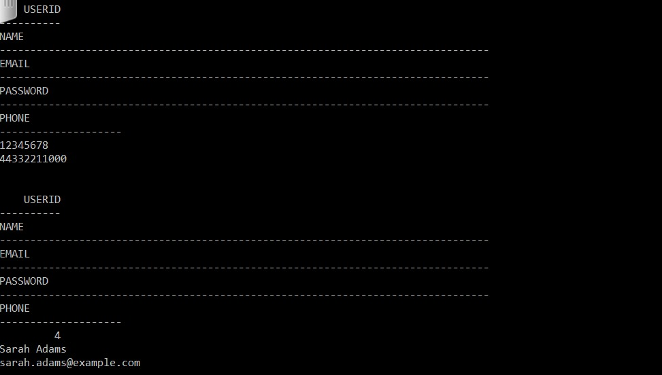

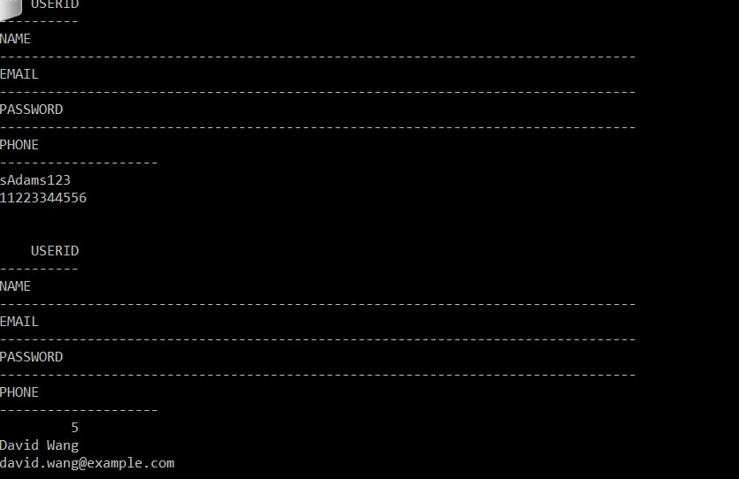

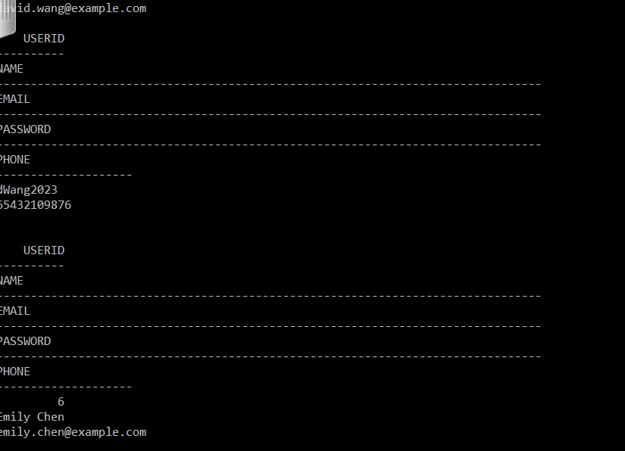

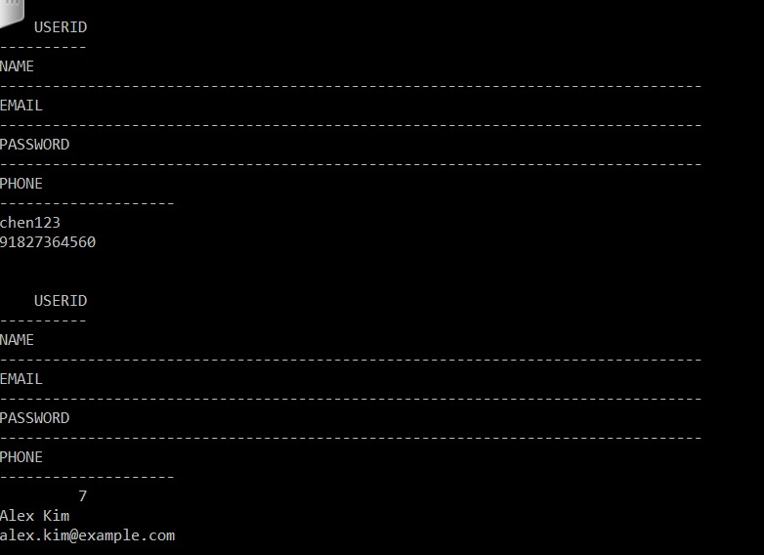

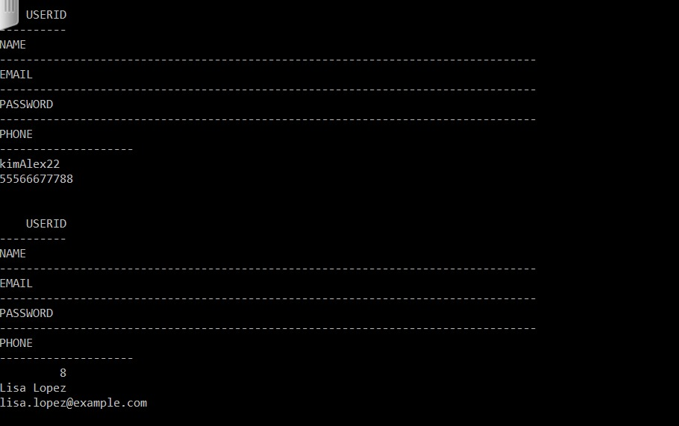

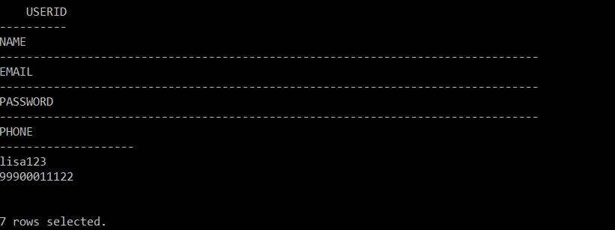

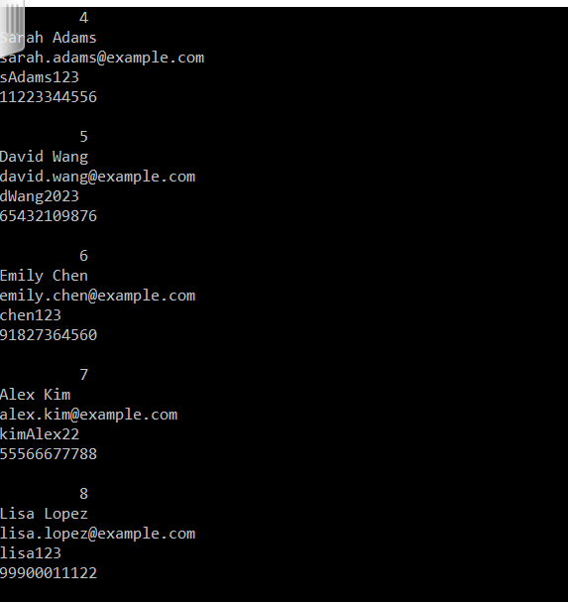

1. Display the details of users whose email addresses end with "@example.com" and have a phone number starting with "+9876."

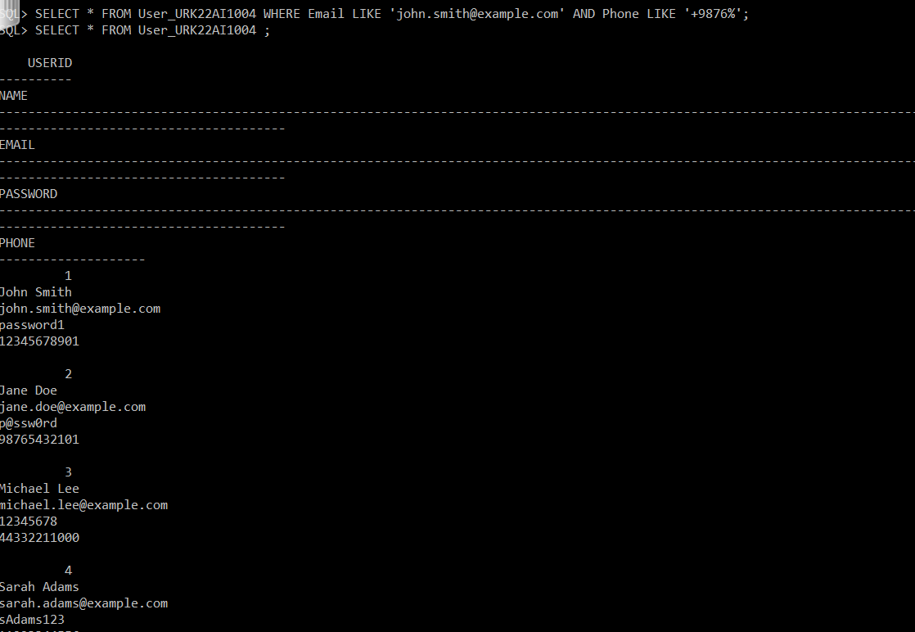

1. Display the details of users whose UserID is either 2, 4, or 6.

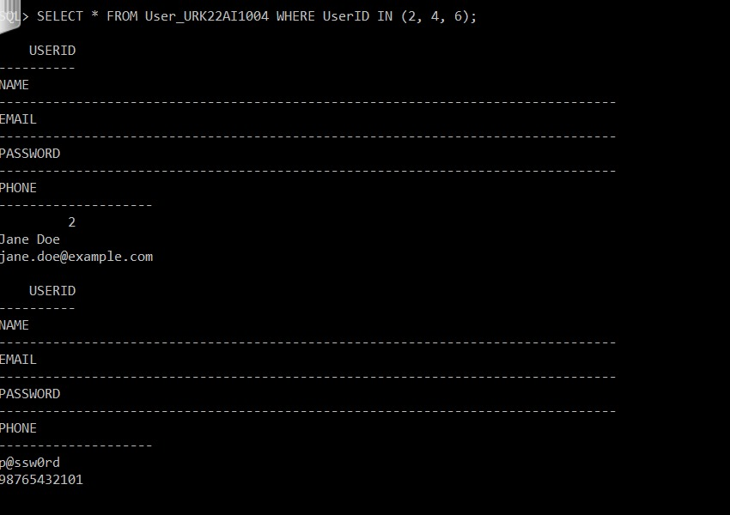

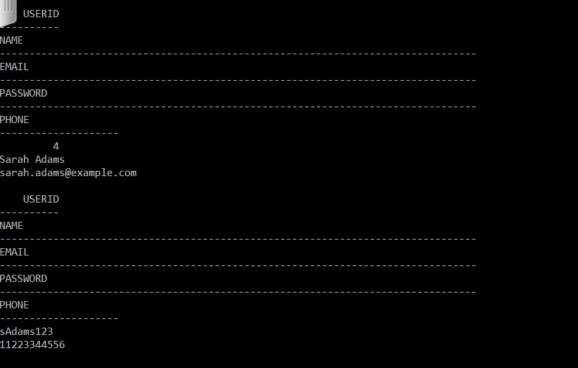

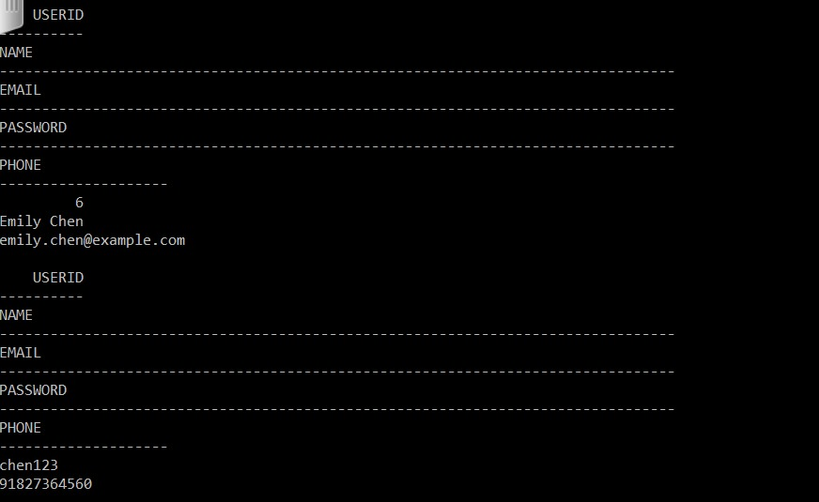

1. Retrieve the details of events that are scheduled to take place after September 15, 2023.

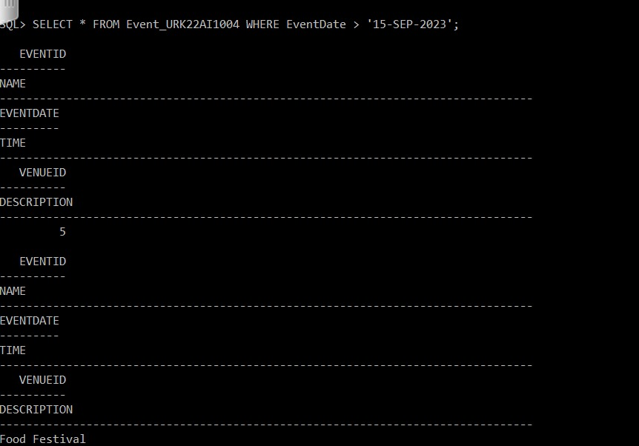

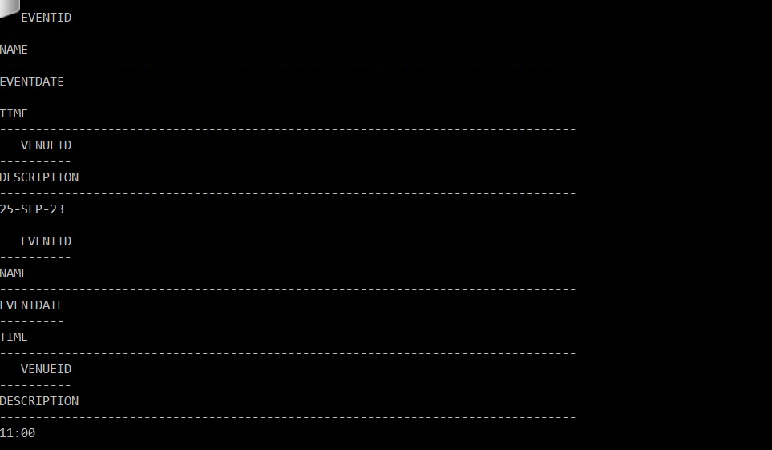

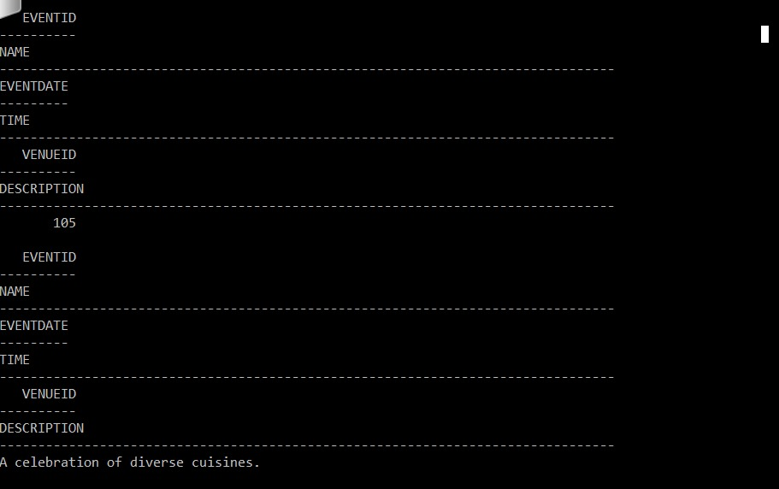

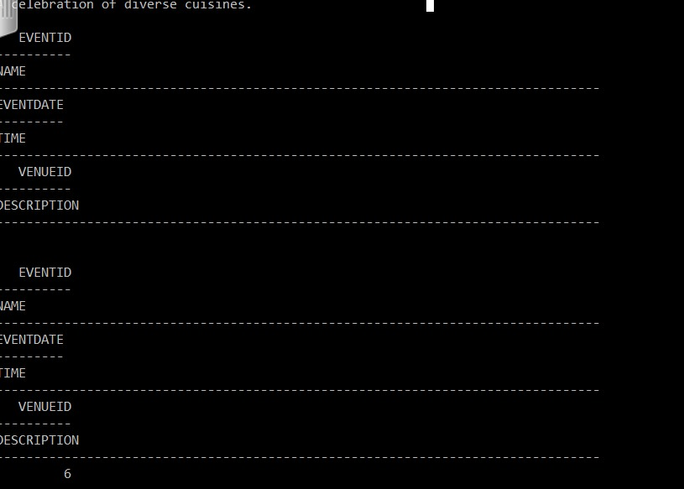

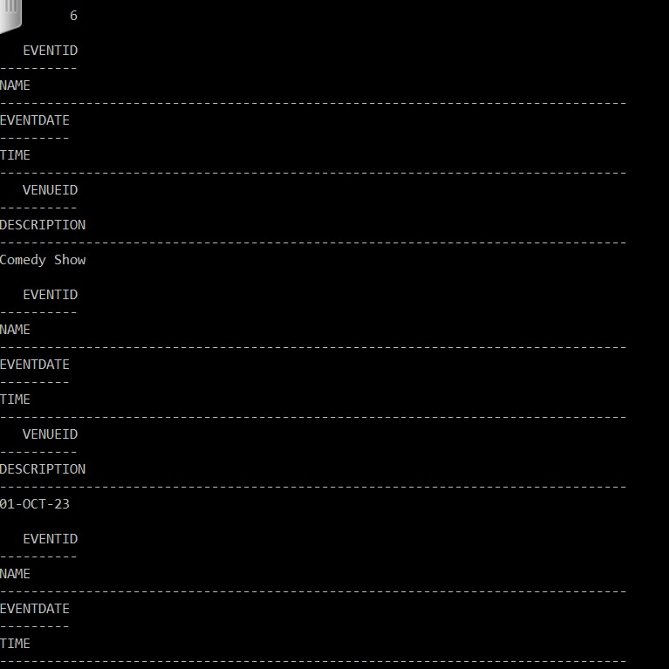

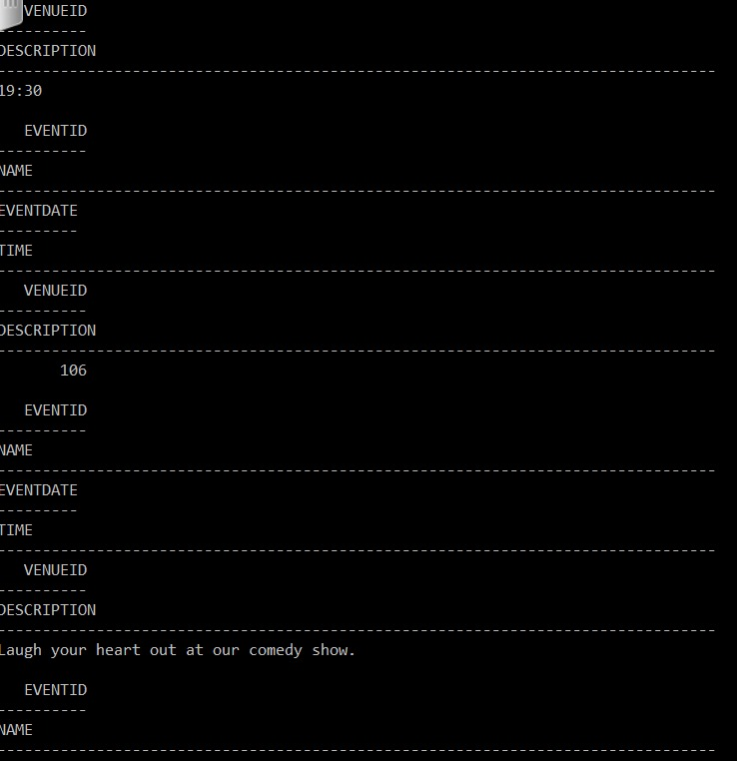

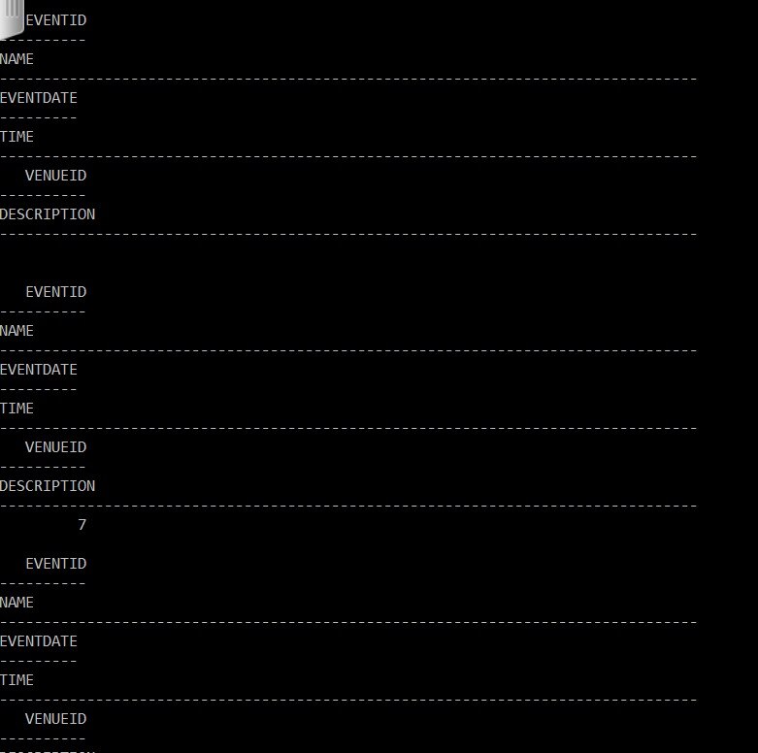

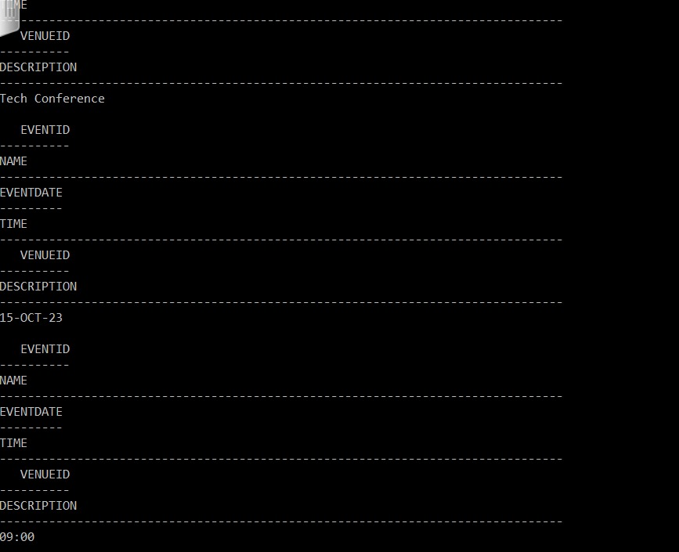

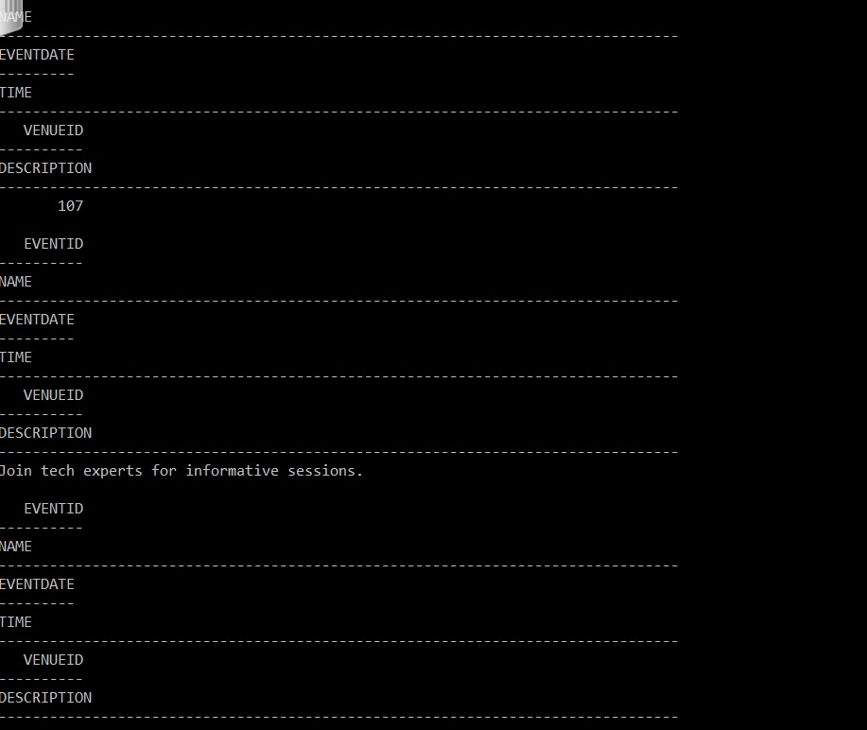

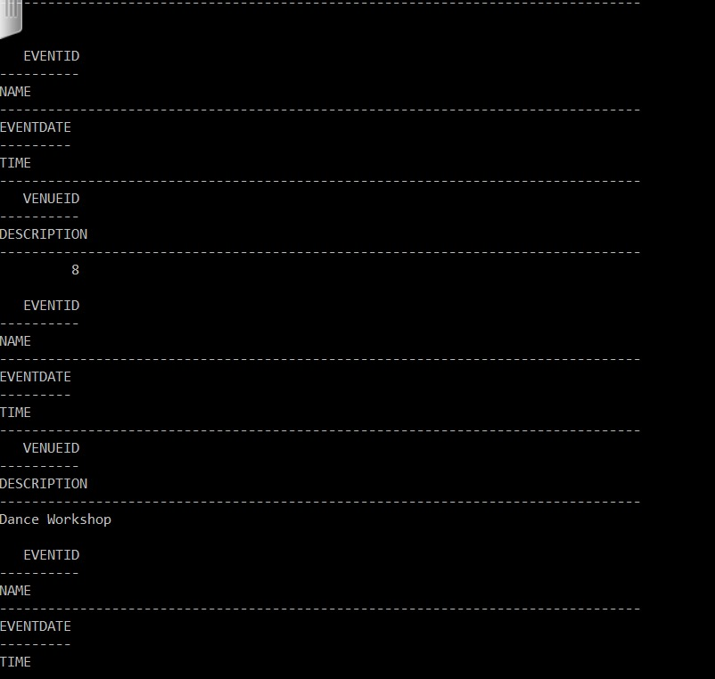

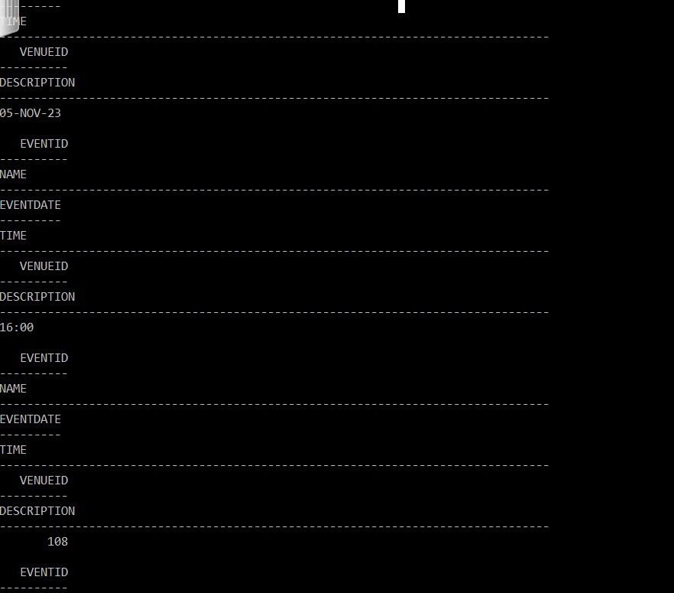

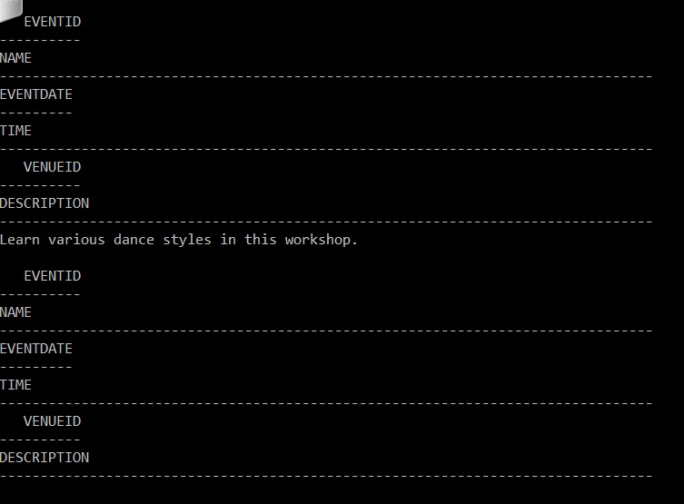

1. Retrieve the details of events that are scheduled to take place after September 10, 2023, and have a VenueID greater than 105.

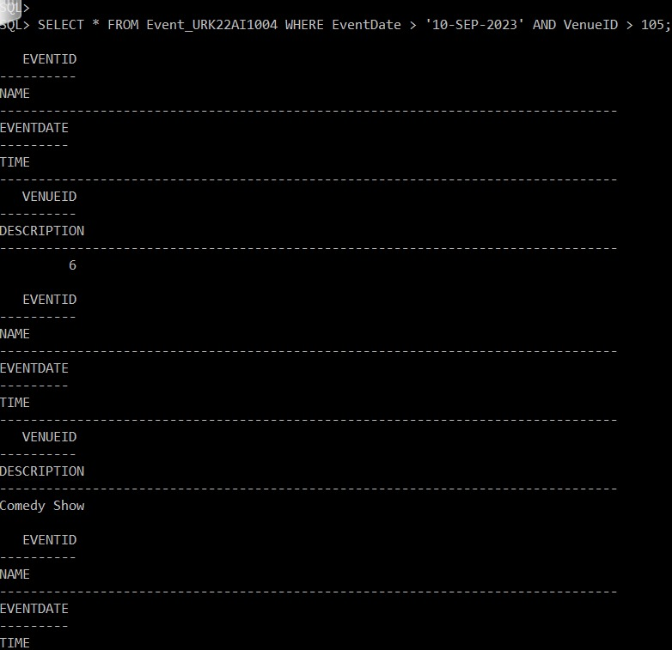

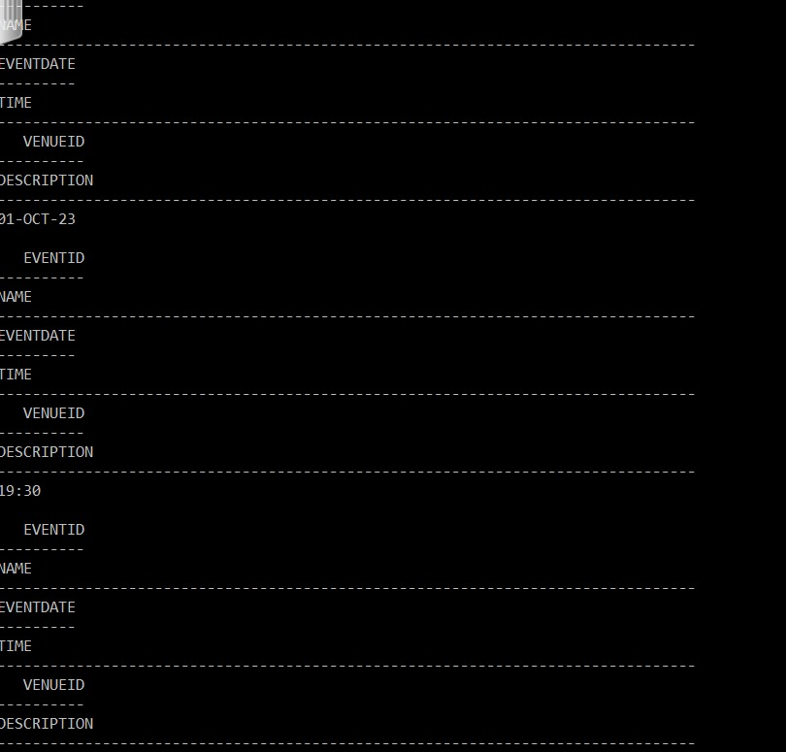

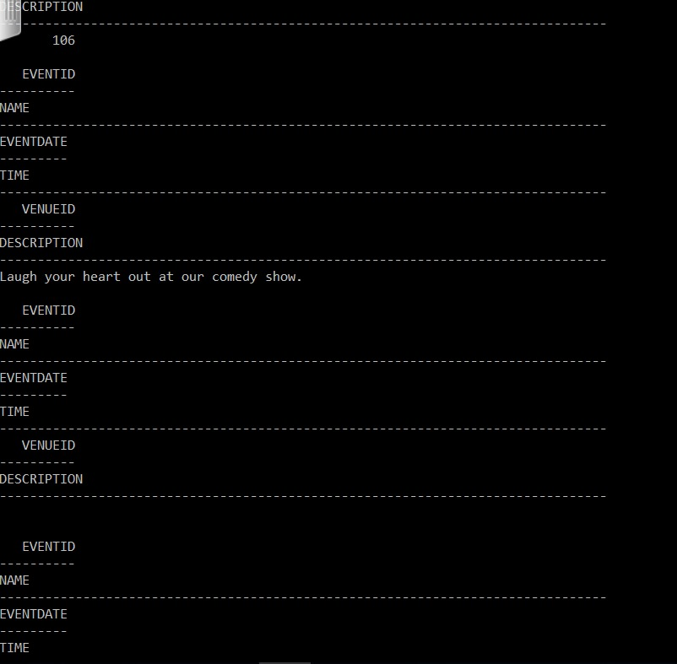

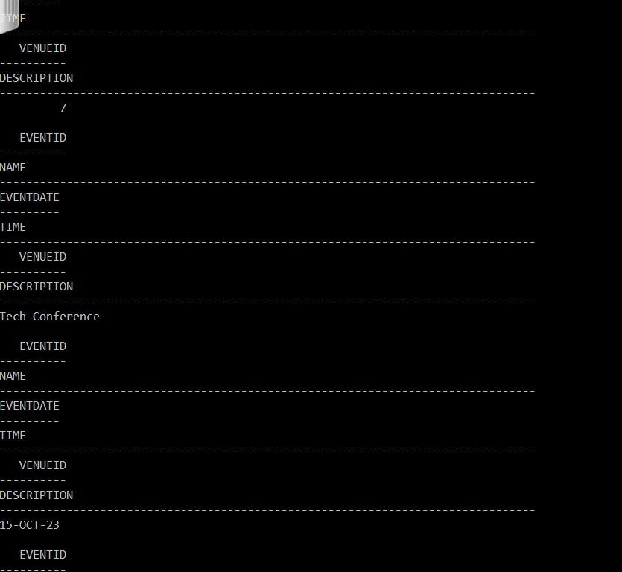

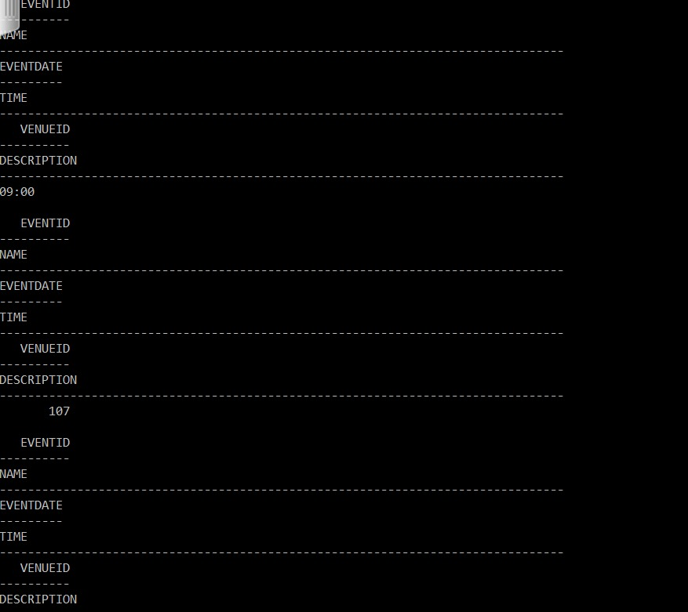

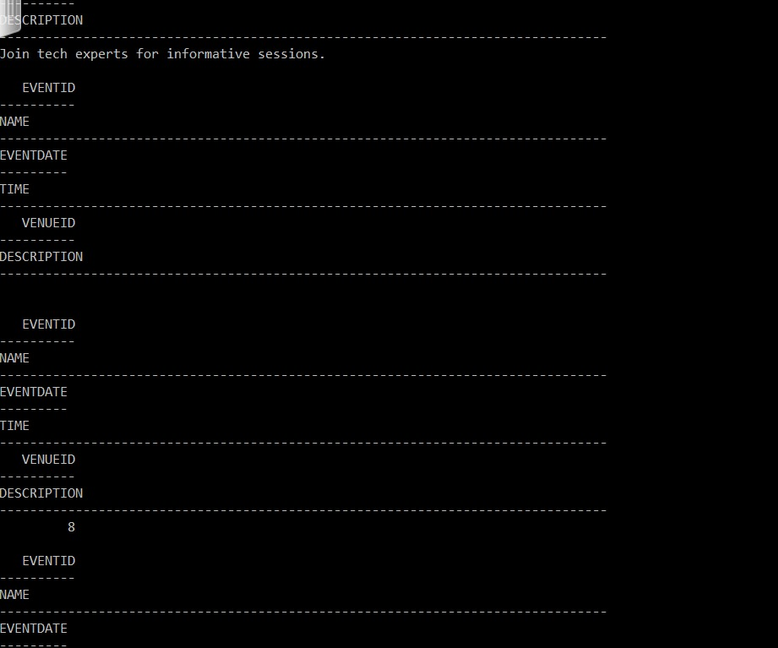

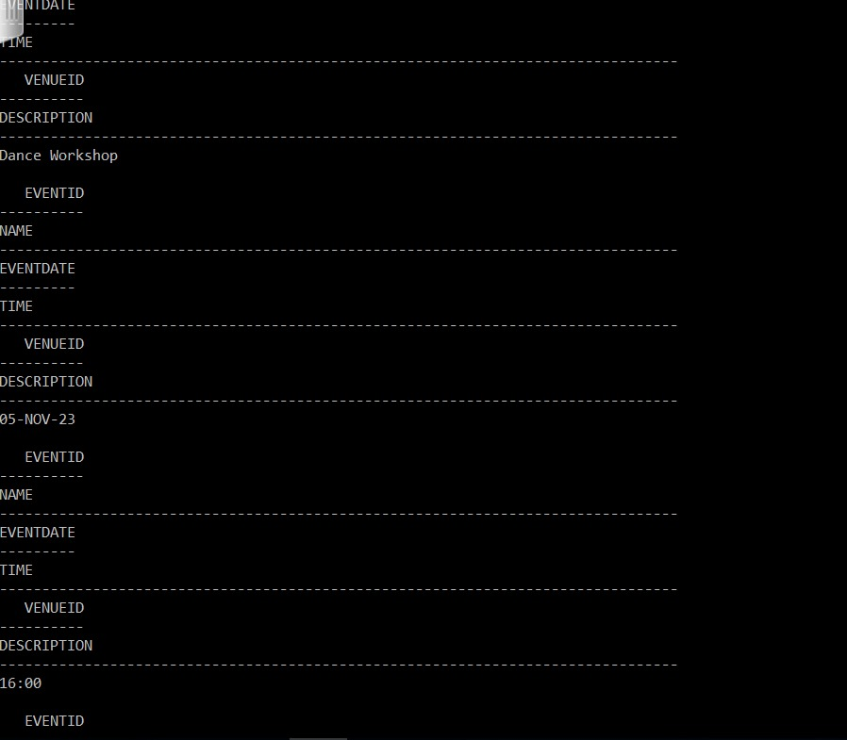

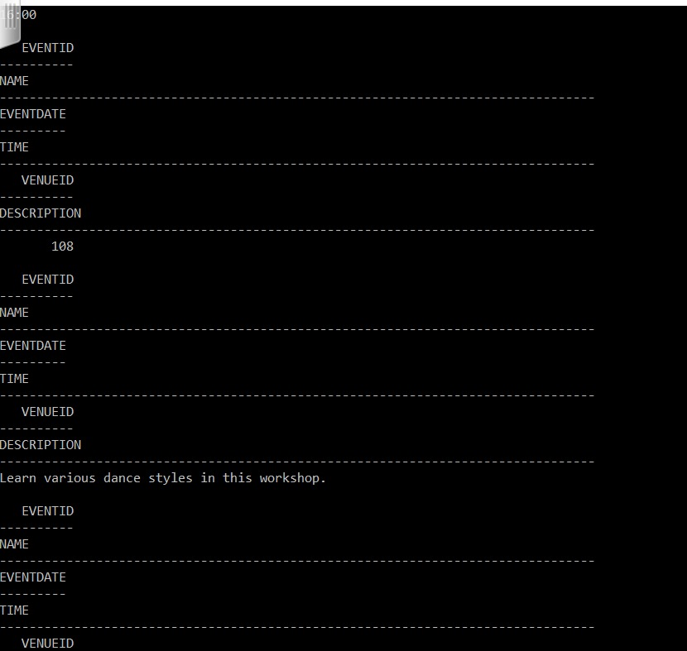

7. Retrieve the details of events that have a name containing "Concert" or "Show" in their name.

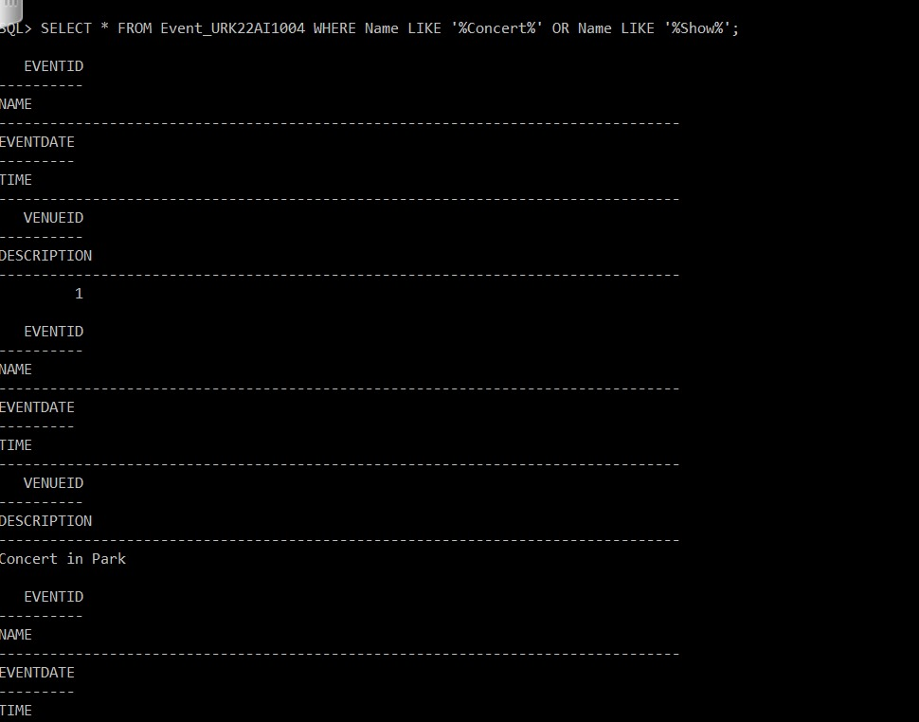

8. Increase the ticket prices for all booked tickets by 5 units.

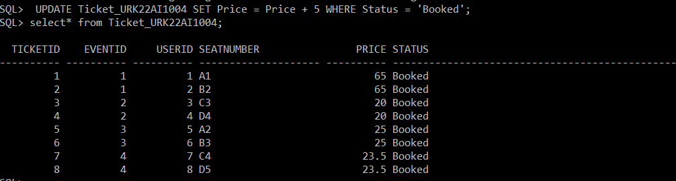

9. Reduce the ticket prices for EventID 2 by 10 units.

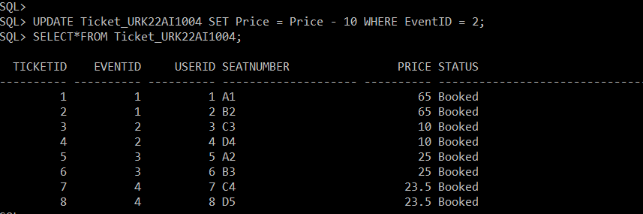

10. Double the ticket prices for tickets with a status of "Booked" and an EventID of 1.

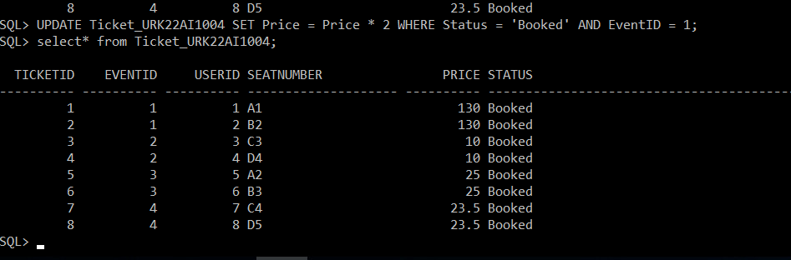

11. Increase the ticket prices for tickets with a status of "Booked" and a price less than 20 by 5 units.

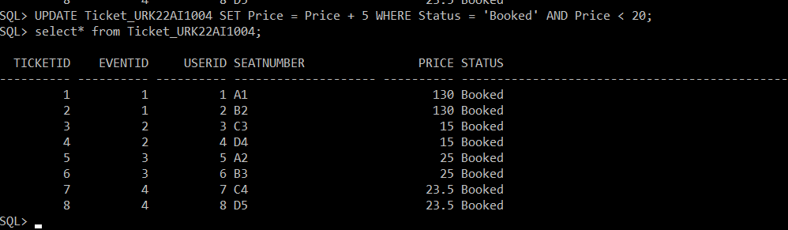

12. Increase the VenueID for EventID 3 to 110.

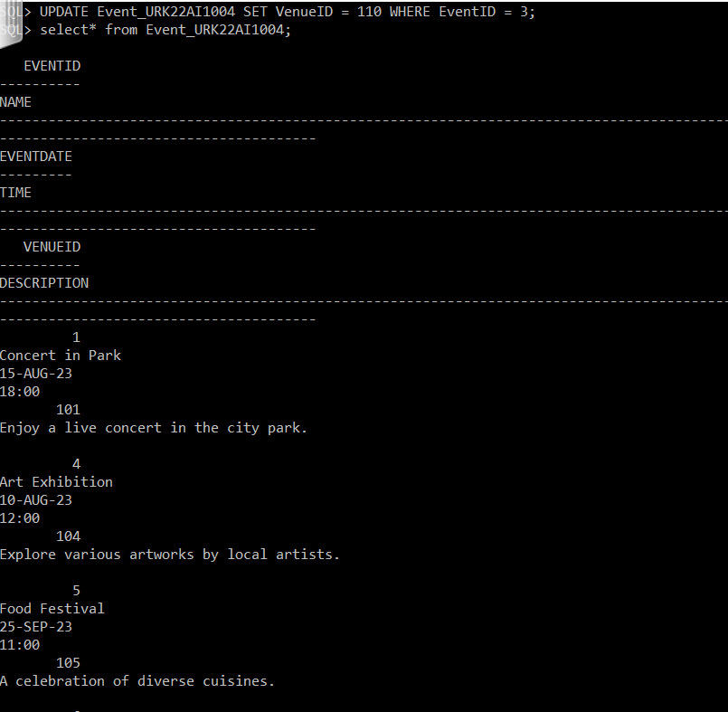

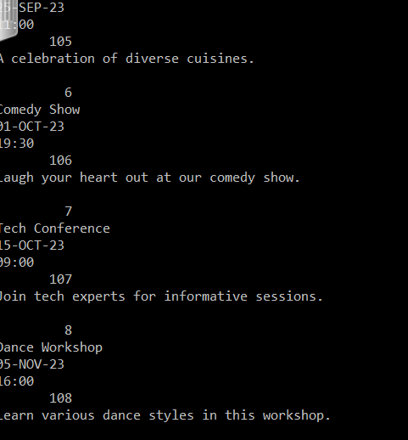

13. Retrieve the details of events that are scheduled to take place on or after 20-09-2023.

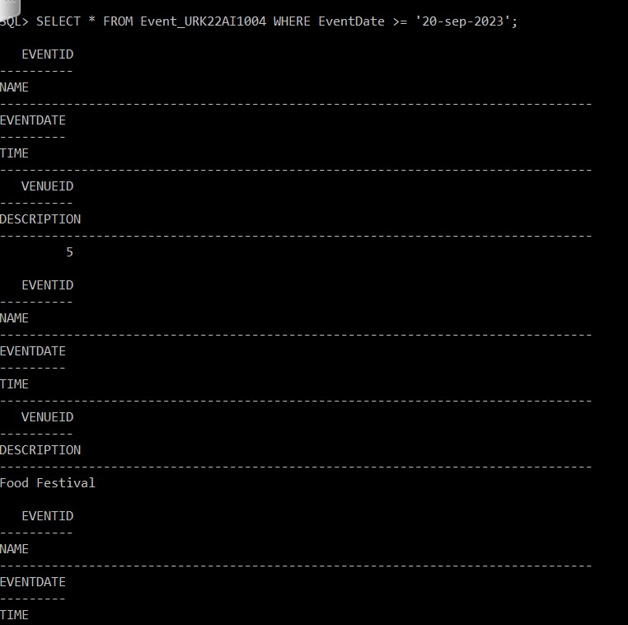

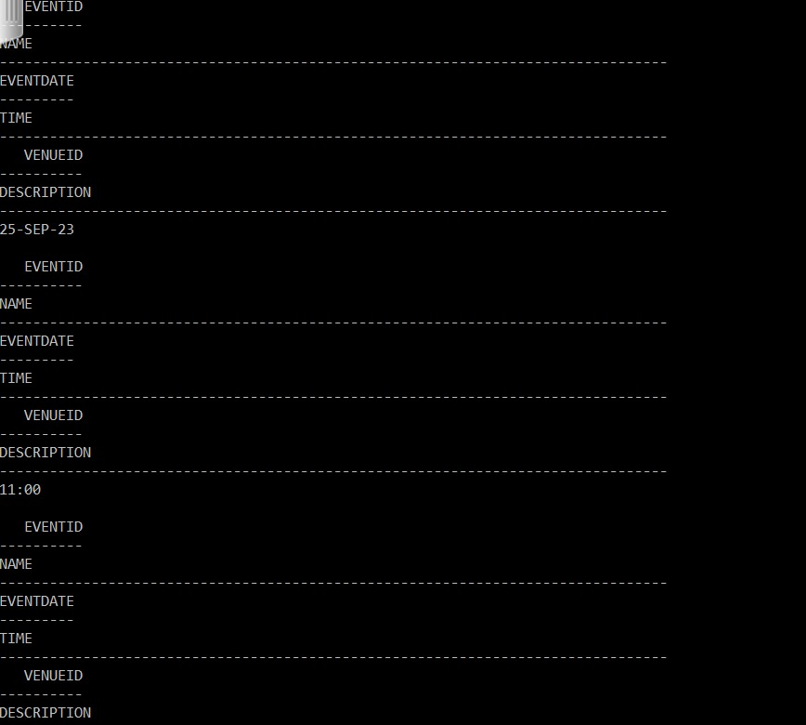

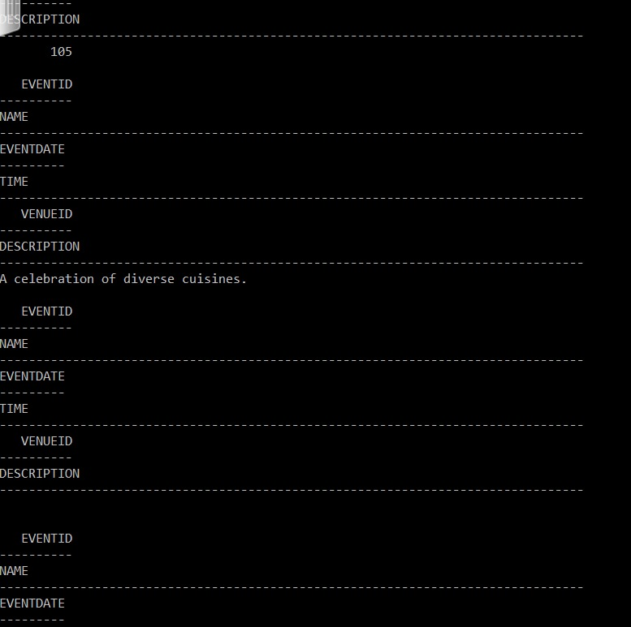

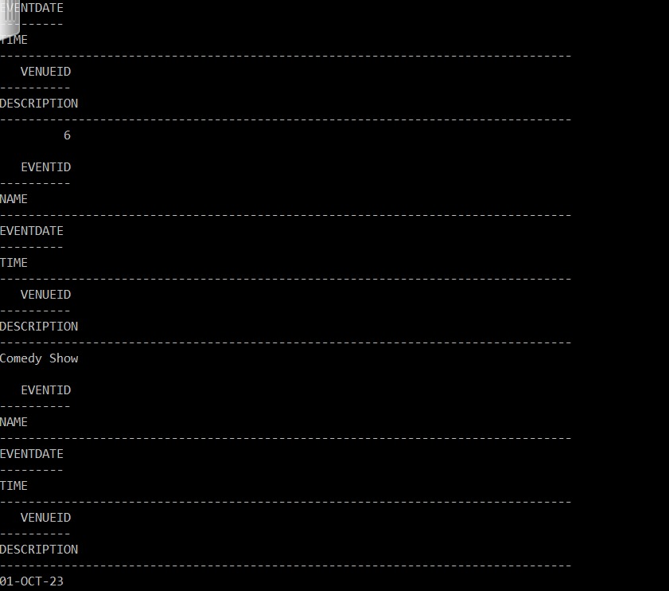

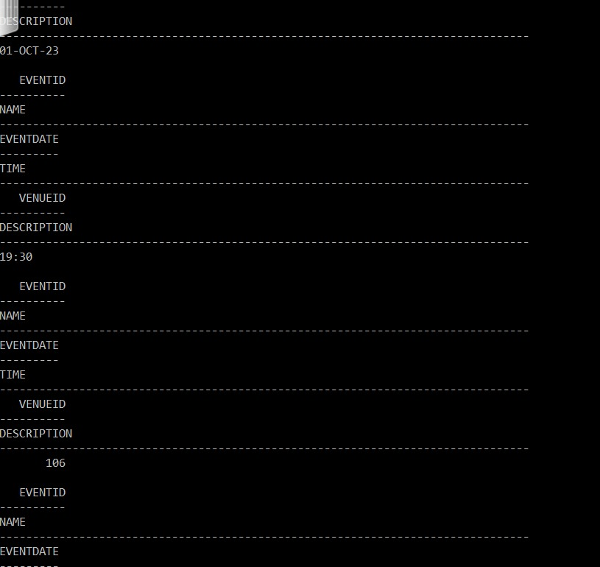

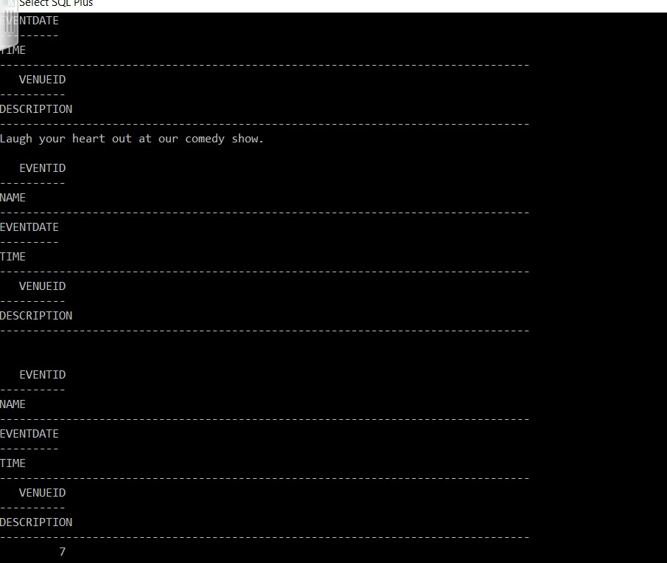

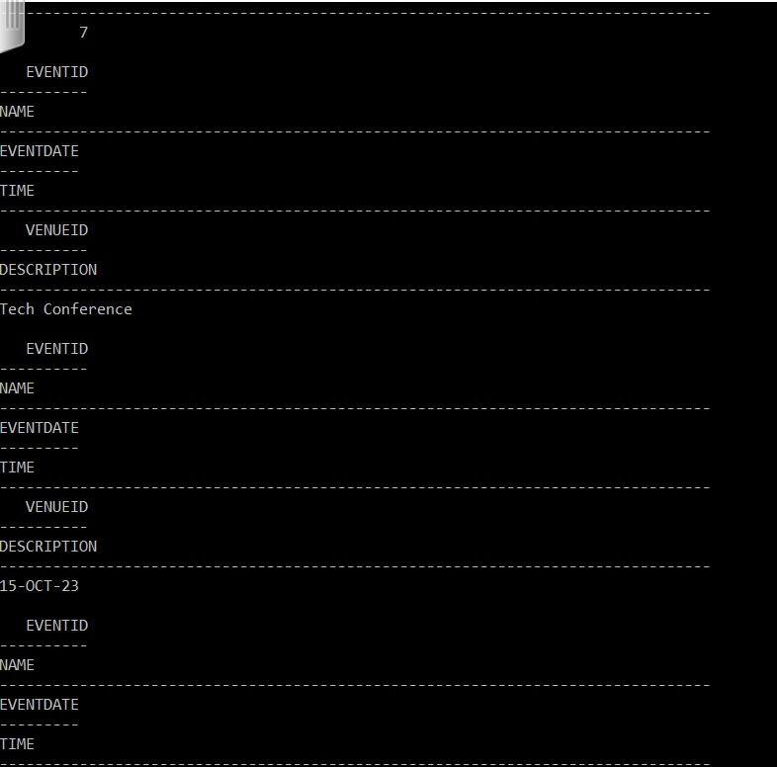

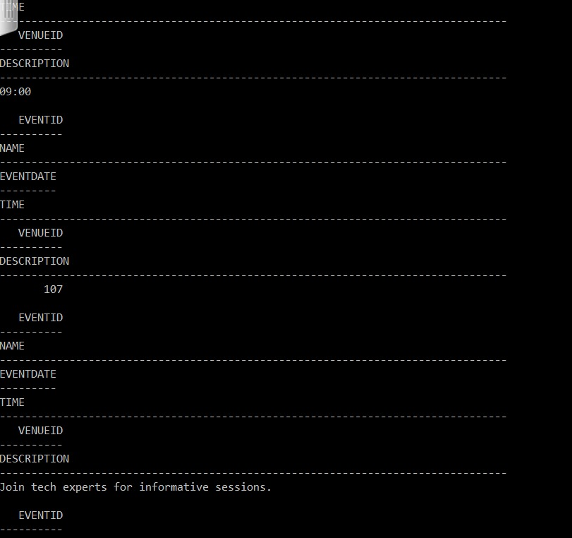

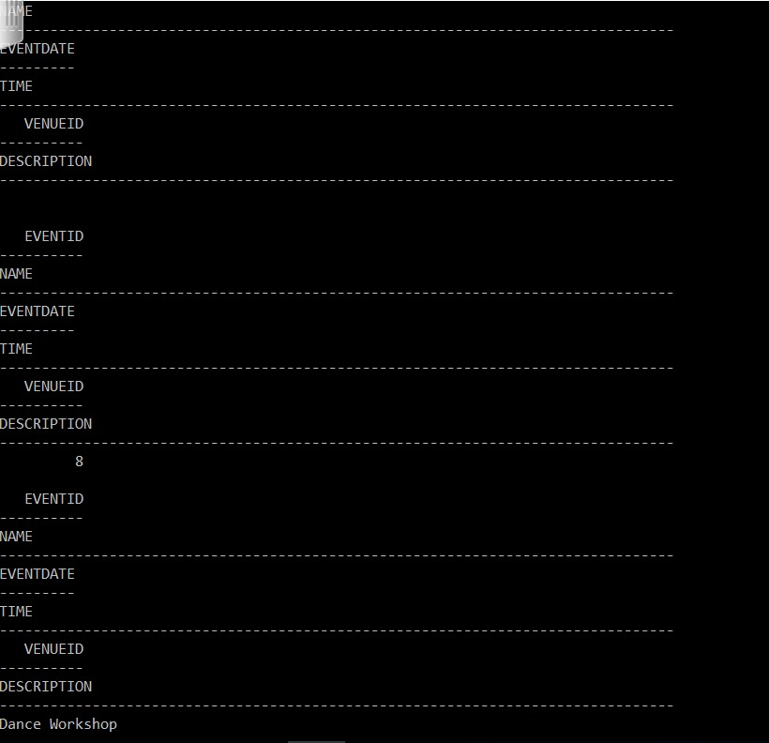

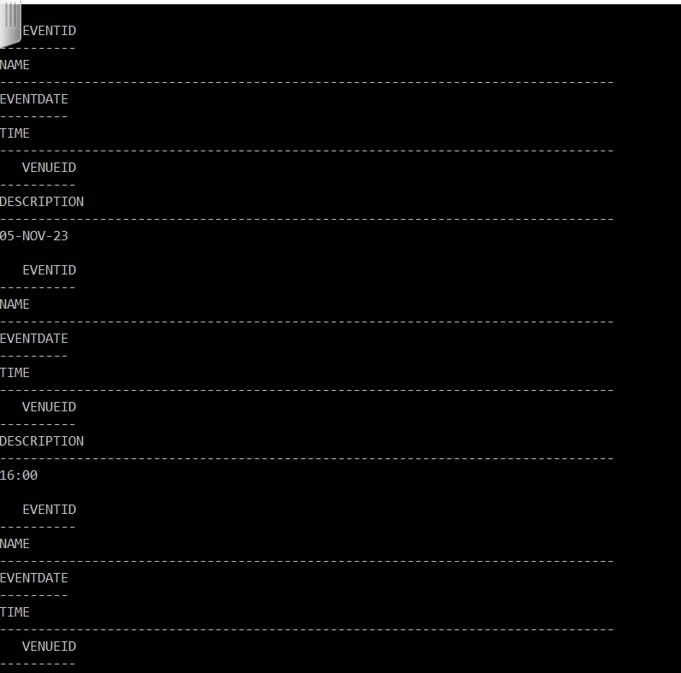

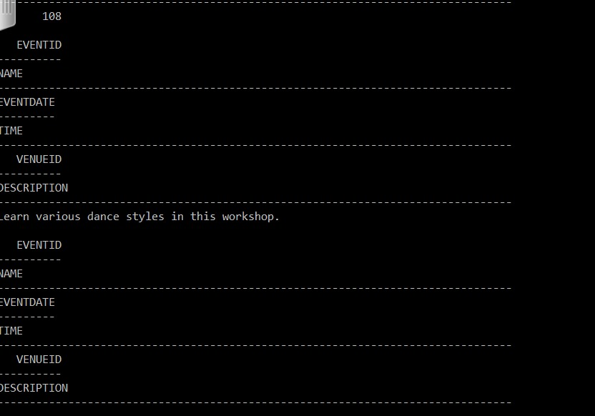

14. Delete the event with EventID 2.

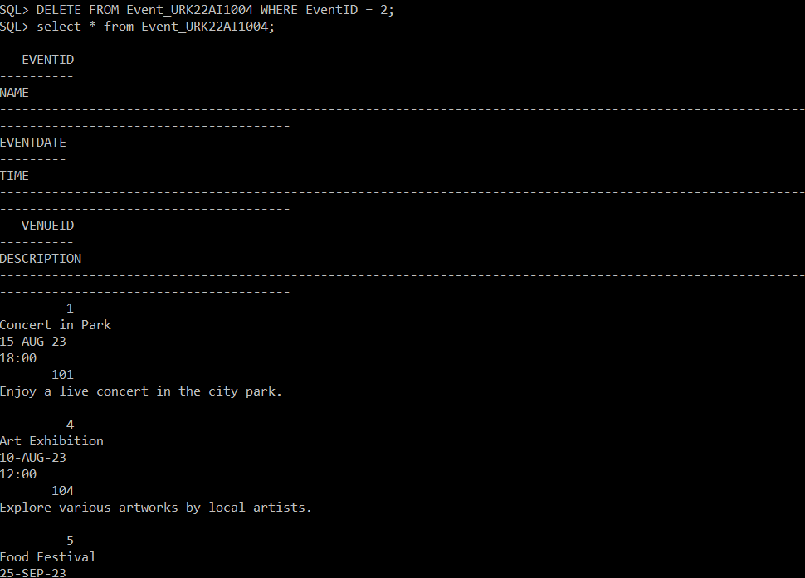

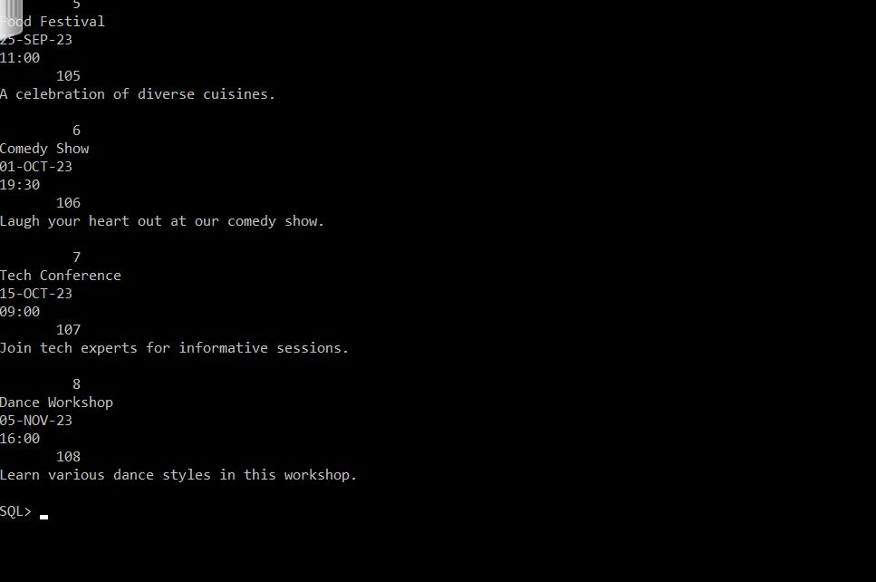

15. Display the details of events that have a description containing the word "workshop."

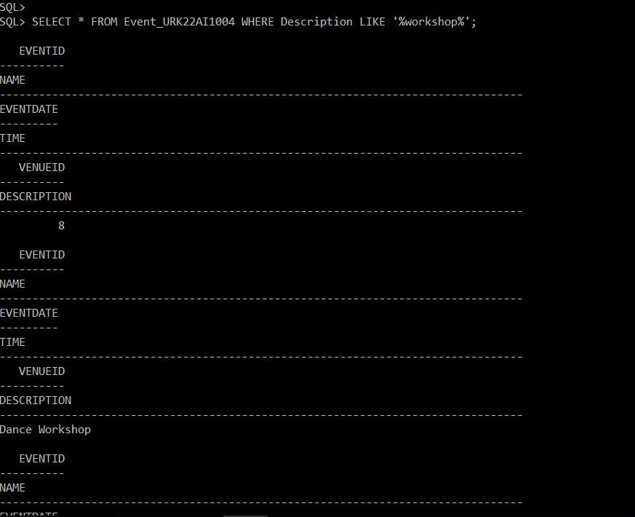

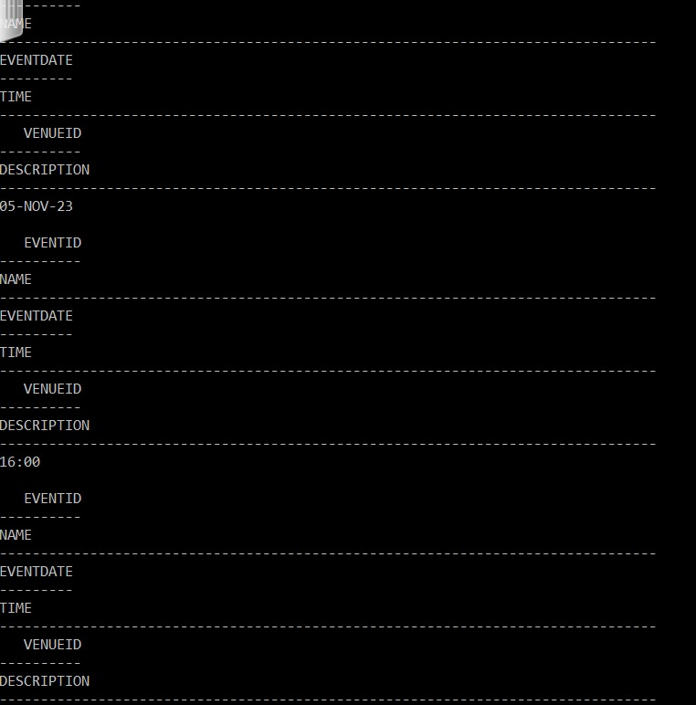

RESULT:

The tables were created and DDL commands were executed successfully.